**Project Part 2**

**Computing Technology Project (COS10026)**

**SUBMITTED BY:**

Hoang Don Xuan Vinh

ID:105545302

**SUBMITTED TO**

Mr. Tristan Nguyen

**DATE OF SUBMISSION:**

**28/3/2025**

**I/Introduction**

**a) Website Introduction**

In modern times, the Internet plays an important role in connecting with people and easing our life in different ways. With this mindset, at SFC we have developed a website to promote and employ potential workers for the availability of technology-related positions. Hence, we’ll take a close look at SFC’s website in this report – its design, functionality, overall user experience and sufficient job information for those who may have interest in applying for a position.

**b) Objective**

The purpose of this report is to display clearly the content of the website, the structure, style and key features of the website that was applied.

**c) Report Structure**

The report will be presented by the following structure:

First, I would explain how we made the website more accessible for people who have visibility problems, such as color-blindness or visual impairment. Secondly, I would demonstrate our website’s content, following that by discussing the style and key features that were applied during the project. Finally, I will show what I have contributed to our project and end with the conclusion.

**II/Accessibility Guideline**

**a) Tips and roles to follow to make the web pages accessible**

During the process of developing the web pages, our team has decided to choose a simple font and bigger size so that people can read each context without any difficulties, even for people who have visual impairments. Furthermore, we chose each color carefully, with the background and text color abstract with each other, but at the same time the color can be read by color-blinded people.

**b) Example of the following guidelines**

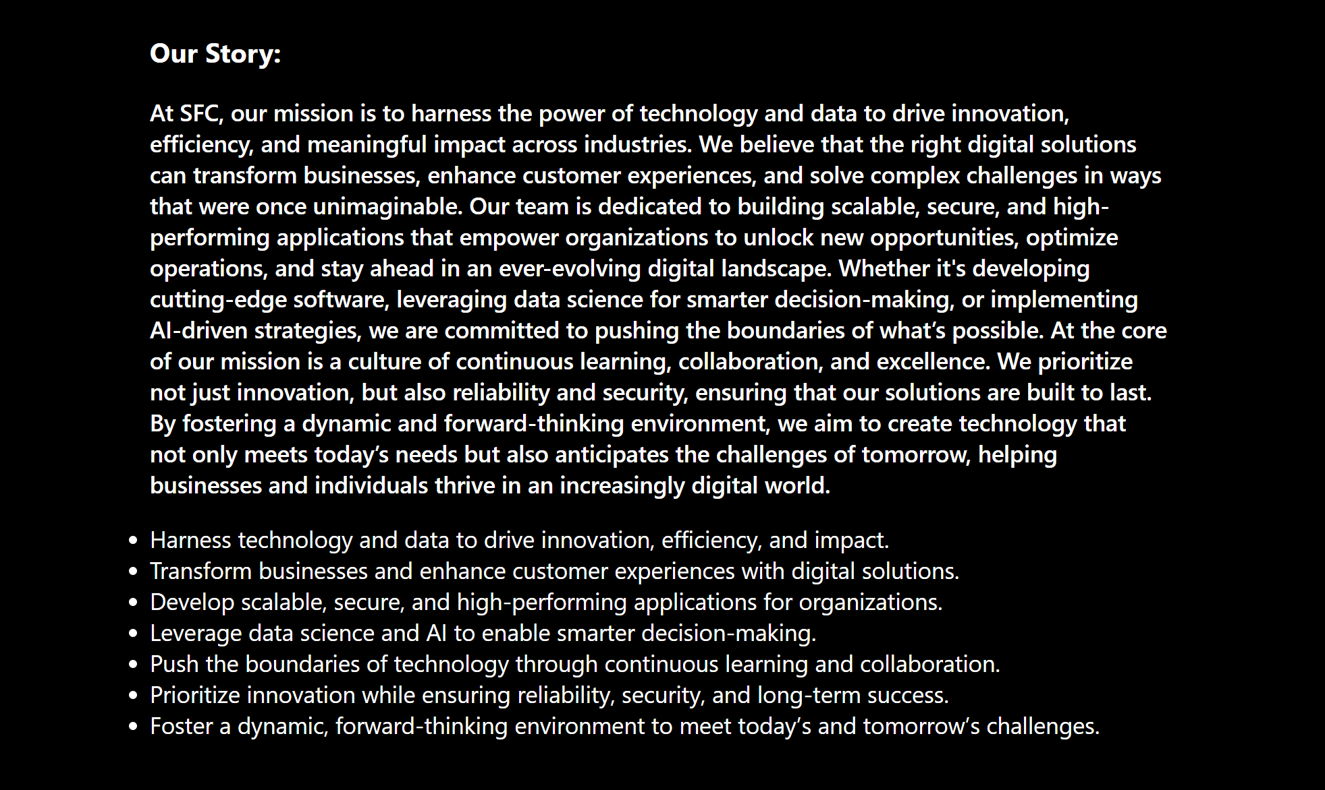

This is an example of how we design our website, The font is simple and quite big. Not only that but the background can differentiate from the text quite easily.

One of the other examples is that we use different images to explicit each position. Each image has a distinguishable color and is easy to see.

**c) Screenshot of WAVE or other accessibility checkers**

**1)**

**2)**

**III/Website content**

There are several web pages included on the website, each serving different purposes.

But before going into the main pages, our website includes smaller elements to make the code simpler to fix, for example header.inc, menu.inc and footer.inc. I will group them into one section as they serve the same purpose and intention. This is an example of one of those features.

* Purpose: each of these files contains lines for header, footer and navigation bar which is usually duplicated in each file as they serve the same purpose, but with these files they can be written easily add them through php and carry on. Furthermore, if any errors occur in these files, it can be easier to detect and fix.
* Technical details: since these files are just a replacement for the html file so they contain the same code. Here’s an example:

**Homepage (index.html)**

* Purpose: It is the first page of the website that provides an overview of how the website is designed and what is about our site. Our homepage is designed to contain a small introduction, redirect to other pages, and a brief description about our page and our mission. Additionally, there is a navigation bar on top of the home page that can help to locate the searchers to other pages through hyperlinks and besides that is our logo.
* Technical details: since this is just an introduction page, it mainly contains texts and related images to best describe our page to the candidates. Therefore, we use mainly <p>, <li> for paragraphs, and <svg> for graphics and <img> for background images. Besides, to improve the user experience, we also create a navigation bar located on top of the page which can help to locate other pages.

**Position description page (jobs.html)**

* Purpose: the company’s position description page serves as a structured and visually engaging platform to showcase job opportunities for potential applicants. The page highlights six positions – Back End Developer, Data Scientist, Full-Stack Developer, Front-End Developer, Data Engineering, and Automation Engineering – each represents with a related-illustrations for easier recognition.
* Technical details: As for the main job page, the website contains 6 job roles structured using a grid layout. By using lazy loading, the images are rendered more efficient. Using JavaScript and CSS, whenever an image is hovered it will display a small summary and a read more button. This can be done through JavaScript function which was named “openPopup” and “closePopup”. By doing this, the amount of content and information for each position can be comfortably displayed.

**Job application page (apply.html)**

* Purpose: The page contains an application form that is easy to use and accessible. It is used to gather all the necessary personal data from potential employees, including name, gender, email address, and the abilities they possess. The candidates must complete a form with all the questions in the proper manner. When candidates click the "Apply" button, a form can gather their information and transmit it to the server for storage.
* Technical details: To create a functional form, the <form> element is essential, along with attributes like **method** and **action**, which determine how the data is sent. The <label> tag helps define each question, making it clear for users. Different <input> types—such as **text, date, and checkbox**—are used to collect various types of information. To ensure all required fields are filled, the **required** attribute is used, while **pattern attributes** help guide users to enter information in the correct format. **Placeholders** provide hints on what to enter in each field, making the form more user-friendly. Finally, buttons are included for submitting or resetting the form, ensuring a smooth experience for users.

**About group page (about.html)**

* Purpose: This page contains essential information about our team, including each member’s name, id and timetable, a group image and most importantly, the team location. There is also a board with the team members’ email address if the candidates want to contact.
* Technical details: each information is divided into groups; each group is written as a list using <ul> and <li>. With the contact section, <a> tags are used to hyperlink emails for easy communication. As for the timetable, <table> element is used to present work schedule. Finally, for the group photo and map, we used a <img> tag for the team and an embedded Google Maps <iframe> for location sharing.

**Enhancements (enhancements.php)**

● Purpose: We use this page to list out all the enhancements that we apply for the website.

● Technical details: unordered list <ul> tag and its child <li> are used to demonstrate all the enhancements that we use.

**Management (manage.php)**

● Purpose: This page is used to display all the candidates and members information and edit this information.

● Technical details: The page is heavily implemented with PHP, allowing the page to connect it to the database, taking information and displaying it through echoing the results that were fetched.

**IV/ Website style**

**Homepage(index.php)**

Since the index.html serves as the website’s introducing page, its main purpose is to draw visitors. The page will contain our company’s name, our slogan and our mission. This section contains 2 container boxes that will lead to our positions page and our member page. To improve the page experience, each element in the page will have an animation, for example when you hover over any of the containing boxes, there will be an animation to indicate that it is being hovered over. And the final section of this page is a small story that is placed in a compact form in the middle of the page.

In every page, we locate the footer and navigation bar to enhance user experience. For the navigation bar, we use small icons that can be easily recognized and when you hover over any of these icons, the name of that page will appear.

In the footer, we want to keep it simple, so we make it smaller than the other elements, but still easy to see and read. Addition to that, we use padding and margin to make it stay in the center and help the content in the page be placed at the middle of the page. The footer will contain our contact information, such as our Facebook page and our mailing address.

**Position description page**

Similarly, the color and style of this webpage is also the same as the index page by using similar properties. Each position description is displayed in a grid so that they will display evenly. When someone is interested in any of those positions, the user can hover over that position, a summary of that position will appear and a read more button if they need more information. This was done by using a combination of JavaScript and CSS. Other necessary properties such as margin, text-align, etc. are used to justify the elements properly. This is an example of three positions:

**About group page**

Our group information is written in multiple unordered lists, and our image is located on the same line as the map by using display: flex, property. Centering all the information and applying borders for each box to make it more rounded.

**Apply**

The application page follows a modern and professional design to create engaging user experience. The navigation bar is consistently placed at the top of the page, ensuring easy access across all sections. It features icon-based navigation, enhancing usability while maintaining a sleek appearance. A dark-themed gradient background is used to provide a stylish and sophisticated look, making the white text stand out for readability.

The form section is designed with user-friendliness in mind, featuring a centered layout with well-spaced input fields. To maintain a clean and structured appearance, the form elements are aligned neatly using padding and margins, ensuring they stay in the middle of the page. Additionally, rounded input fields contribute to a modern aesthetic.

The introductory text at the top of the page serves to engage applicants, emphasizing career opportunities and growth. To enhance visual impact, animations may be applied to elements, making them appear smoothly upon loading. This creates a seamless transition effect that adds to the overall polished look of the page.

**Management**

For the management page which is used to display all the candidates applied and the status of that member or candidate. All the candidate’s information is taken from the database of Swinburne and can be filter through the search bar. Furthermore, there is a delete and edit button so that the admin can change information details. Because this is just a page to display the information, the table is designed to be simple but have enough space to display it nicely.

**Enhancements**

Since this page contains mainly text, its layout just needs to be clear and organized by using margin property.

**V/ Key Features**

This website is designed to advertise job openings within our company by providing potential candidates with comprehensive job descriptions. It utilizes multiple webpage levels to present information progressively. Initially, a general overview of available positions is displayed. If a candidate is interested in a particular role, they can navigate to a more detailed job description page. This structured approach ensures clarity by outlining key responsibilities, required qualifications, and essential skills for each position.

Additionally, the website includes a user-friendly and accessible application form for those who wish to apply. The collected candidate information is securely transmitted to the Mercury server for processing.

**VI/ My Contribution**

For this project, my job is to create the index page, apply page and validate project file.

* Index page: This page was the first one I made, setting the tone and the overall color palette for the whole website, I tried to keep it as simple as possible but also adding small details in each element of the website such as animation or a minimal but elegant font. I also try to make it look a bit more futuristic with a gradient picture that has an inspiration from neon lights.
* Apply page: because this page is just a form application for the candidate to register, it is styled with only a few CSS properties as it just needs to be organized and clear for the users. However, this page required me to focus more on its functionality. Each question is designed with different requirements patterns, ensuring only the correct answer form from the candidate is accepted. For instance, the last name is limited to 20 alpha characters, or the date of birth must be written in the form of date/month/year.
* Management page: This was the hardest page that I did, but with the practical example from the two lab of the class, I was able to do it quite easily.
* For the other members of the group:
  + Vo Cong Minh was responsible for creating the apply page and enhancements page.
  + Dang Le Trieu Duong handling the about us page.
  + Truong Minh Tinh was the designer for the CSS and job positions page.
* Validation: after our group finishes developing the website, my job is to check and validate our code by using a website validator to eliminate all the possible errors.

**VII/ Conclusion**

In summary, our project aims to promote job opportunities in the field of artificial intelligence. The website's design, structure, and core functionalities are thoughtfully implemented to ensure seamless user experience. It effectively presents job details while maintaining a user-friendly and accessible interface. Each page's layout and formatting are carefully designed to enhance readability and visual appeal, and further improvements will be made in the future.